Aircraft Design 1 – Fall 2025

Assignment 1: Analysis of Requirements, Concepts, and Fuselage Design

Student Names and USCIDs:

Aurelio Santiago, C30461119

Mateo Garcia, V02125756

Jacob Chin, C96554174

Instance 1

Hours spent on assignment: 47h

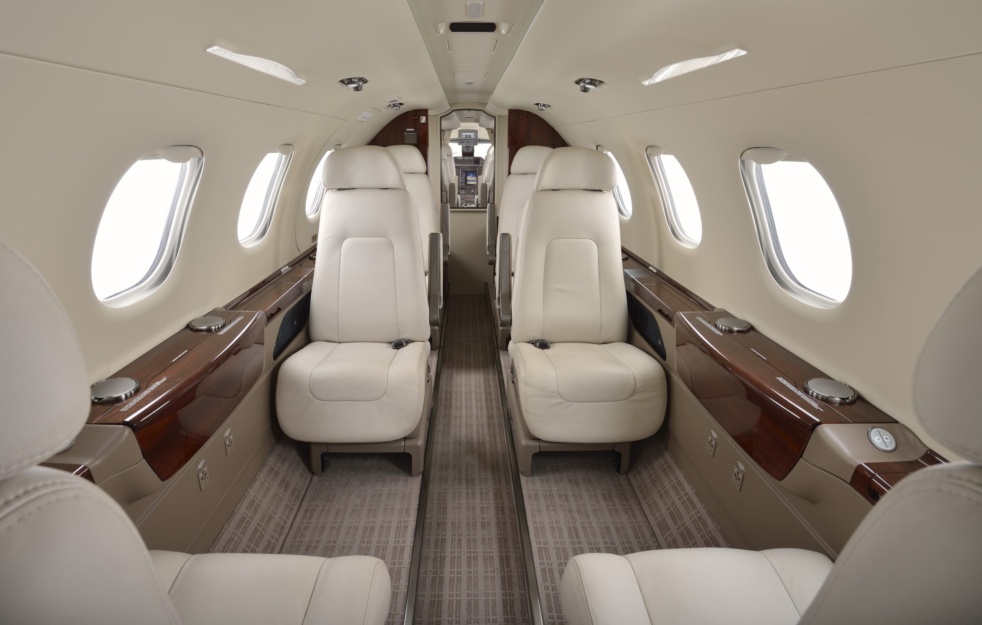

Aircraft type: Business Jet

Aircraft number: 110

Table 1: Requirements Table

|  |  |  |
| --- | --- | --- |
| Requirement type | Value | Unit |
| Payload | 1100 | kg |
| Max Payload Weight |  |  |
| Range | 3600 | km |
| Cruise Altitude |  |  |
| Cruise speed | 830 | km/h |
| Take-off distance | 1200 | m |
| Landing distance | 860 | m |
| Propulsion System | jet |  |

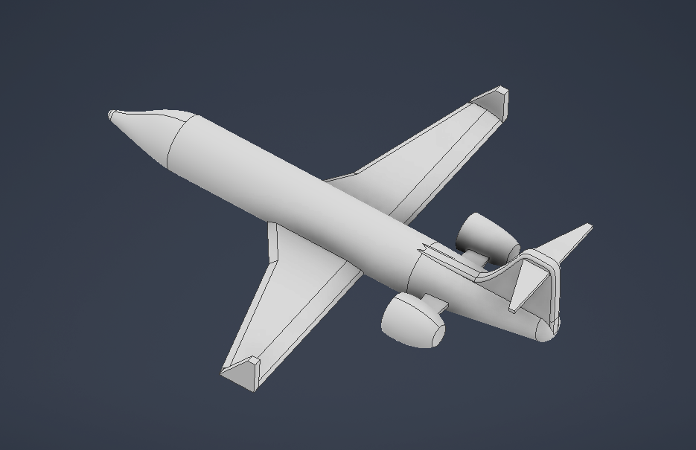

**Table of Contents**

1. Introduction 4

2. Mission Definition and Requirements Analysis 4

2.1 Mission Profile 4

2.2 Requirements Analysis 5

2.2.1 Payload Analysis 5

2.2.2 Propulsion Analysis 6

2.2.3 Certification Analysis 6

2.2.4 Performance Analysis 6

2.2.5 Additional Requirements 7

2.2.6 Driving Requirements 7

3. Reference Aircraft Data Collection 7

4. Concept Designs and Selection 8

4.1 Concept Generation 8

4.1.1 Rear Mounted Twin Jet Configuration 9

4.1.2 Twin Tail and Horizontal Stabilizer Configuration 9

4.1.3 Over the Wing Engine Mount Configuration 10

4.1.4 Tri-Jet Engine configuration 11

4.2 Concept Selection 11

5. Fuselage Design and Layout 12

5.1 Interior Fuselage Layout 12

5.1.1 Regulation Considerations 12

5.1.2 Cabin Design Approach 12

5.1.3 Fuselage Cross Section 13

5.1.4 Emergency Exits 14

5.1.5 Cabin Floor Plan 14

5.1.6 Design Flexibility 16

5.1.7 Visibility & Cockpit/Nose Design 16

5.2 Nose length 17

5.2.1 Tail Plane & Wings 18

5.2.2 Tail Design 18

5.2.3 Landing Gear 18

Sources and References: 18

Appendix 1: Aircraft parameters table 21

Appendix 2: Aircraft technical drawings 22

Appendix 3: Table of Reference Aircraft 27

# 1. Introduction

In this report, there are four main sections: Mission Definition and Requirements, which will define the mission parameters and how they affect the design; Reference Data Collection, which will comprehensively include all of the reference aircraft influencing the design; Conceptual Design, which will present 3 possible rough concepts to fit the aforementioned requirements and select one to be finalized; Fuselage Design, where the detailed study and design of the fuselage will take place, including precise measurements and accommodations. Following these main sections there will be references and appendices for relevant information that are referenced throughout the report.

# 2. Mission Definition and Requirements Analysis

This section will define the mission parameters for this aircraft as well as various requirements such as payload accommodations, possible propulsion systems, certifications, and other such defining factors of the design.

## 2.1 Mission Profile

The mission profile is practically identical to that of a commercial aircraft. It begins at engine start and ends with the engine turning off. A deeper explanation of each step follows Figure 2.

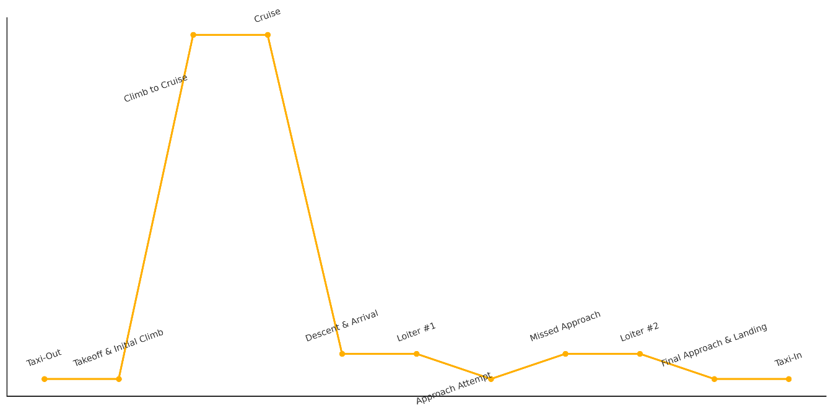

Figure 2 - Mission Profile

The figure above shows a complete mission profile of what will be used as the standard expected flight profile of this aircraft. The steps are as follows:

1. **Engine Start:** This is where the profile starts, after the payload is secured and pre-flight checks are finished.
2. **Taxi-Out:** After the engine is started, the aircraft makes its way to the runway before preparing to take off.
3. **Take-off & Initial Climb:** The aircraft accelerates and takes off to begin the initial stages of climbing and orienting itself to the proper air traffic route. A critical point for design.
4. **Climb:** After the initial climb and orientation, the aircraft continues climbing and accelerating to cruise altitude and cruising speed.
5. **Cruise:** The aircraft reaches cruising altitude and speed; it remains at this stage for much of the flight time (depending on the destination).
6. **Descent & Arrival:** The aircraft begins its descent toward the destination, communicating with ground crew to determine when and where to land.
7. **Loiter #1:** The aircraft may have to loiter in the air before being told to land, depending on air traffic and if the flight itself is on time.
8. **Approach Attempt:** The aircraft attempts to land on the indicated runway.
9. **Missed Approach:** For the purposes of this design, assume the first approach fails due to runway issues or aircraft issues that may require a second attempt.
10. **Loiter #2:** The aircraft once more loiters in the air waiting for an opportunity to land on another runway.
11. **Final Approach & Landing:** The aircraft approaches and makes a successful landing on the indicated runway. Another critical point for design.
12. **Taxi-In:** After landing, the aircraft makes its way to the proper disembarking area for the payload to be removed (or, in this case, to remove themselves).

## 2.2 Requirements Analysis

This section will describe the various requirements to achieve the intended goal of the aircraft. The obvious main goal will be to safely transport the payload from one place to another intact. However, extra requirements to do so include proper accommodation for the payload and necessary crew, an appropriate propulsion system for the rough estimated size and range, certification requirements, and other such defining features that will influence design priorities.

## 2.2.1 Payload Analysis

The payload as described in Table 1 is 1100 kg combined load of passengers and their luggage. Based on airline survey data, the average passenger is 84kg and brings roughly 24kg of luggage (including one carry-on and one standard luggage), meaning the average passenger in total brings 108kg of payload on the aircraft. Given the 1100 kg requirement, this indicates a minimum of 11 passengers on the aircraft. For redundancy and symmetry, assume accommodations for 14 passengers.

Requirements for pilots and crew only technically include the pilots, as flight attendants are only mandatory for 19+ passengers. However, accommodations for at least one flight attendant will be included. Pilots and crew will bring an additional 324kg to the aircraft.

In total, pilots, crew, and passengers will be assumed to bring 1836kg onto the aircraft.

In terms of volume occupied by passengers and crew, governed by the chart in Reference 1, they will be assumed to bring about 2.686 m3 of luggage onboard (0.158 m3 per person assuming one large carry-on and one large checked suitcase). Again, for redundancy and accommodating for the possibility of extra-large items needing to be stored the design can allocate 4-5 m3 for cargo space.

Space for pilots and the flight attendant will also be considered and included, though this technically is not part of the payload.

## 2.2.2 Propulsion Analysis

As listed in the requirements, this aircraft will need a jet engine, though there are certainly many types that fit this category. Generally, for business jets, it is typical to use either turbofan or turbojet engines. For the intended relative size of this aircraft, it will be far more fitting to use turbofan engine(s). It would be possible to use quite a few engine configurations in terms of placement, such as a single centrally mounted engine or twin side mounted engines. These configuration options will be discussed more in Section 4 Concept Designs and Selection.

## 2.2.3 Certification Analysis

Due to the intended use of the aircraft, it would fall under the Transport category of FAA Airworthiness Certification, which is Subchapter C, Part 25 of FAA Regulations. Requirements under this section involve flight control, structure, onboard equipment, the engine system (or powerplant), operating limitations, passenger capacities, and other special regulations. All of these sections will become relevant as this aircraft develops, but for this report the focus will be on passenger limitations (based on relative size), fuselage structure requirements, and some part of powerplant requirements (in simpler terms of how it affects the conceptual design with placement of engines).

## 2.2.4 Performance Analysis

Within the other given parameters are other strict requirements for the minimum performance of the aircraft. Take-off and landing distances are to be 1200m and 860m respectively, which will impact the design of the landing gear configuration, wing configuration, and control surfaces. Also listed is the necessary minimum range of 3600 km, which will influence the space necessary for fuel and possibly induce certain weight limitations as well. Though more detail will be given for these systems later, this report will include rudimentary concepts and estimations for capacities and weights to get a general grasp on how they will meet the requirements.

## 2.2.5 Additional Requirements

Along with main requirements there are also supplemental requirements that address other necessities on the aircraft. Due to the operating altitude, cabin pressurization is necessary and will be addressed directly in fuselage design, as it adds weight and more complex elements in the structural design. There are also regulations on fuel capacity accounting for loitering and being able to go to another airport if necessary. Loitering was included in the mission profile and will be in the calculations of necessary fuel on the aircraft along with the regulatory extra amount.

## 2.2.6 Driving Requirements

For this aircraft, the driving considerations (following safety and stability) will be comfort, efficiency, and range. Comfort will be first, considering this aircraft is intended to be used by high level business personnel; next would be efficiency, with the goal being to make this a more “cost-effective” aircraft to be a solid selling point to businesses; finally there is a range consideration, in order to ensure that the aircraft only has to stop midway for fuelling on the longest of trips. For comfort, the fuselage will be designed with ample space in mind for all passengers, lavatories, galley(s) and possible configurations for extra high-end additions (such as a small bar, a larger food prep area, or possibly meeting space). Efficiency and range will be affected by the engine and wing configurations, which will be considered here, but the finer details about these two factors will come up later in the design process.

## 3. Reference Aircraft Data Collection

Reference aircraft data provides valuable information for evaluating the design concept against aircrafts that have already been fielded and validated. A wide range of aircrafts with similar specifications have been research to provide a reference of maximum and minimum for key parameters. The full table for reference aircraft data is in Appendix 3. Some columns have missing information; this is due to a lack on data provided by manufacturers. Below is a condensed table highlighting the aircraft that most strongly informed the configuration choices. The tables will be updated as additional data are verified and as the design evolves.

|  |  |  |  |  |  |  |  |
| --- | --- | --- | --- | --- | --- | --- | --- |
| **Manufacturer** | **Type** | **Crew** | **Passengers** | **MTOW (kg)** | **BOW (kg)** | **Max Payload (kg)** | **Fuel (kg)** |
| Bombardier | Learjet 60 | 2 | 8 | 10659 | 6700 | 1011 | 3588 |
| Embraer | Phenom  300E | 2 | 10 | 8150 | 5344 | 1196 | 2428 |
| Cessna | Citation Latitude | 2 | 9 | 13971 | 8462 | 1258 | 5168 |
| Gulfstream | G100 | 2 | 7 | 11181 | 6515 | 1195 | 4248 |
| Pilatus | PC-24 | 2 | 10 | 8500 | 5316 | 1406 | 2705 |
| Bombardier | Challenger 300 | 2 | 8 | 17622 | 11022 | 1588 | 6418 |
| Fairchild Dornier | 328Jet Envoy | 3 | 15 | 15660 | 9420 | 3650 | 3634 |

*Table 3.1: Sample Aircraft Reference Data from Appendix 3*

# 4. Concept Designs and Selection

## 4.1 Concept Generation

In this section, four distinct concept configurations were developed to provide a diverse range of aircraft design options for evaluation. These include a rear-mounted twin-jet engine configuration, twin tail and horizontal stabilizer design, an over-wing engine configuration, and a tri-jet engine arrangement. By exploring this variety of concepts, a broader range is established for comparison and performance assessment. The following subsections present a better detailed description of each configuration, highlighting their respective strengths and weaknesses.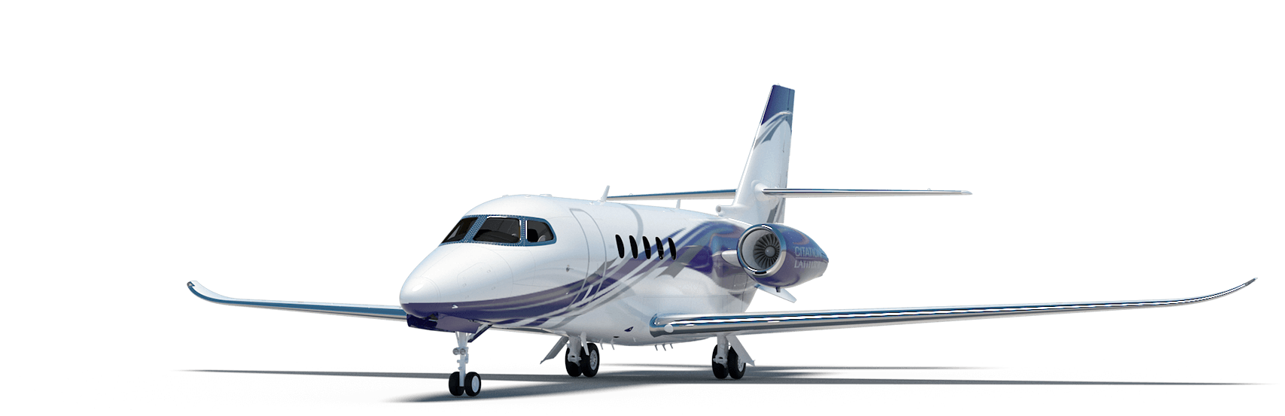

Rear Mounted Twin Jet Configuration

* Two pylon mounted tail engines
* Low wing configuration
* Conventional tail design

*Figure 4.1: Cessna Latitude [1]*

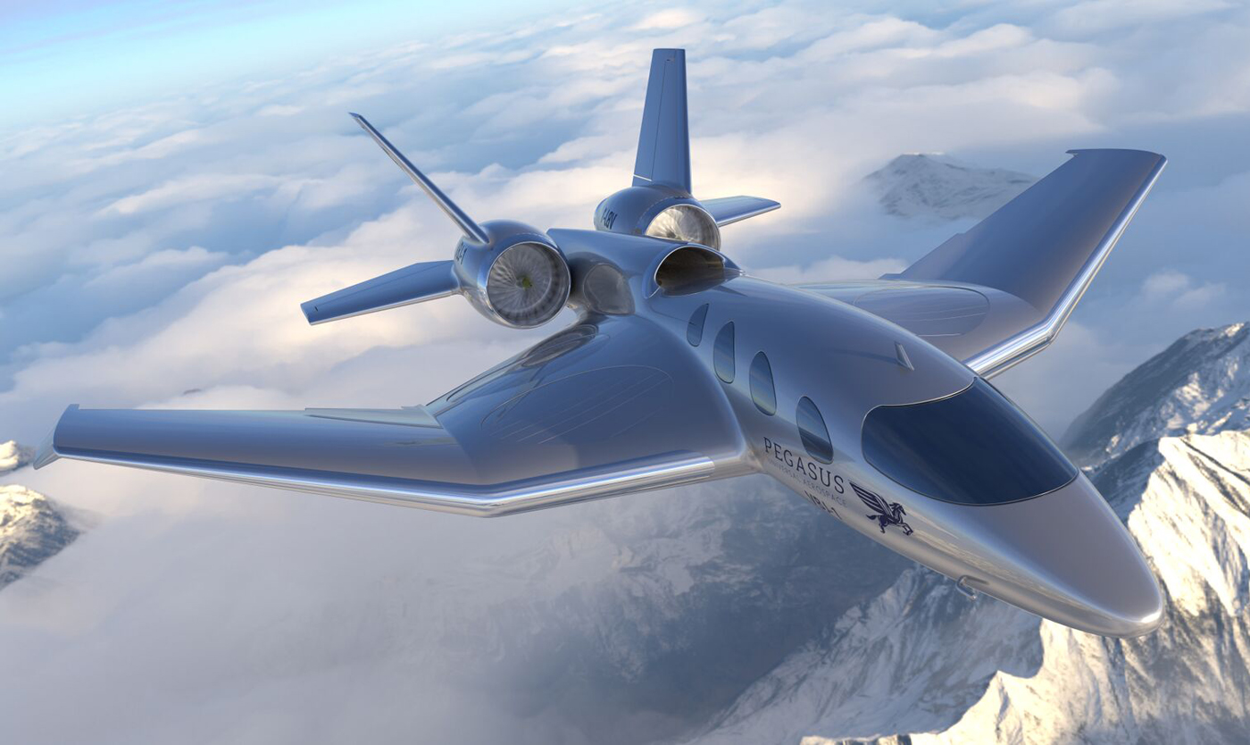

Twin Tail and Horizontal Stabilizer Configuration

* Two fuselage mounted engines
* Low wing configuration with winglets
* Twin tail and horizontal stabilizers configuration

*Figure 4.2: Pegasus VBJ [2]*

Over the Wing Engine Mount Configuration 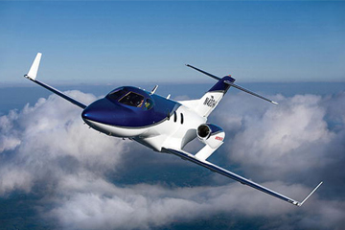

* Two engines mounted on pylons above the wing
* Low wing configuration with winglets
* Conventional tail design

*Figure 4.3: HondaJet [3]*

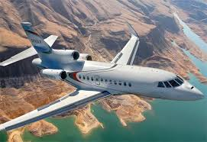Tri-Jet Engine Configuration

* Three fuselage mounted engines
* Low wing configuration
* Conventional tail design

*Figure 4.4: Dassault Falcon 900 [4]*

## 4.1.1 Rear Mounted Twin Jet Configuration

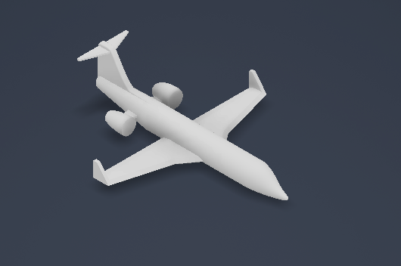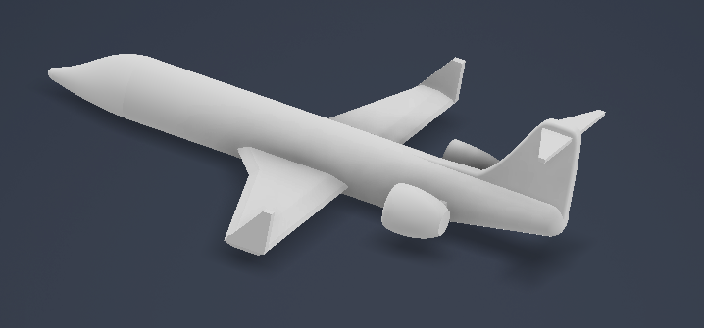

*Figure 4.5: Rear Mounted Twin Jet Configuration*

The rear-mounted twin-jet layout is a time-tested configuration that has been widely used in the business jet market. provides several advantages for business jet operations. By maintaining a clean wing free of underwing nacelles, the configuration improves aerodynamic efficiency and allows high-lift devices to function effectively, which directly supports short take-off and landing requirements. Passenger comfort is also considered, as the cabin experiences reduced noise levels compared to under-wing mounting. However, a drawback of this design is its center-of-gravity sensitivity, which complicates loading, and structural crowding at the end of the fuselage, where systems, fuel, and engines must all be integrated. Despite these challenges, the configuration has strong precedent and offers reliable performance for the specified mission. Additionally, the low wing placement

## 4.1.2 Twin Tail and Horizontal Stabilizer Configuration

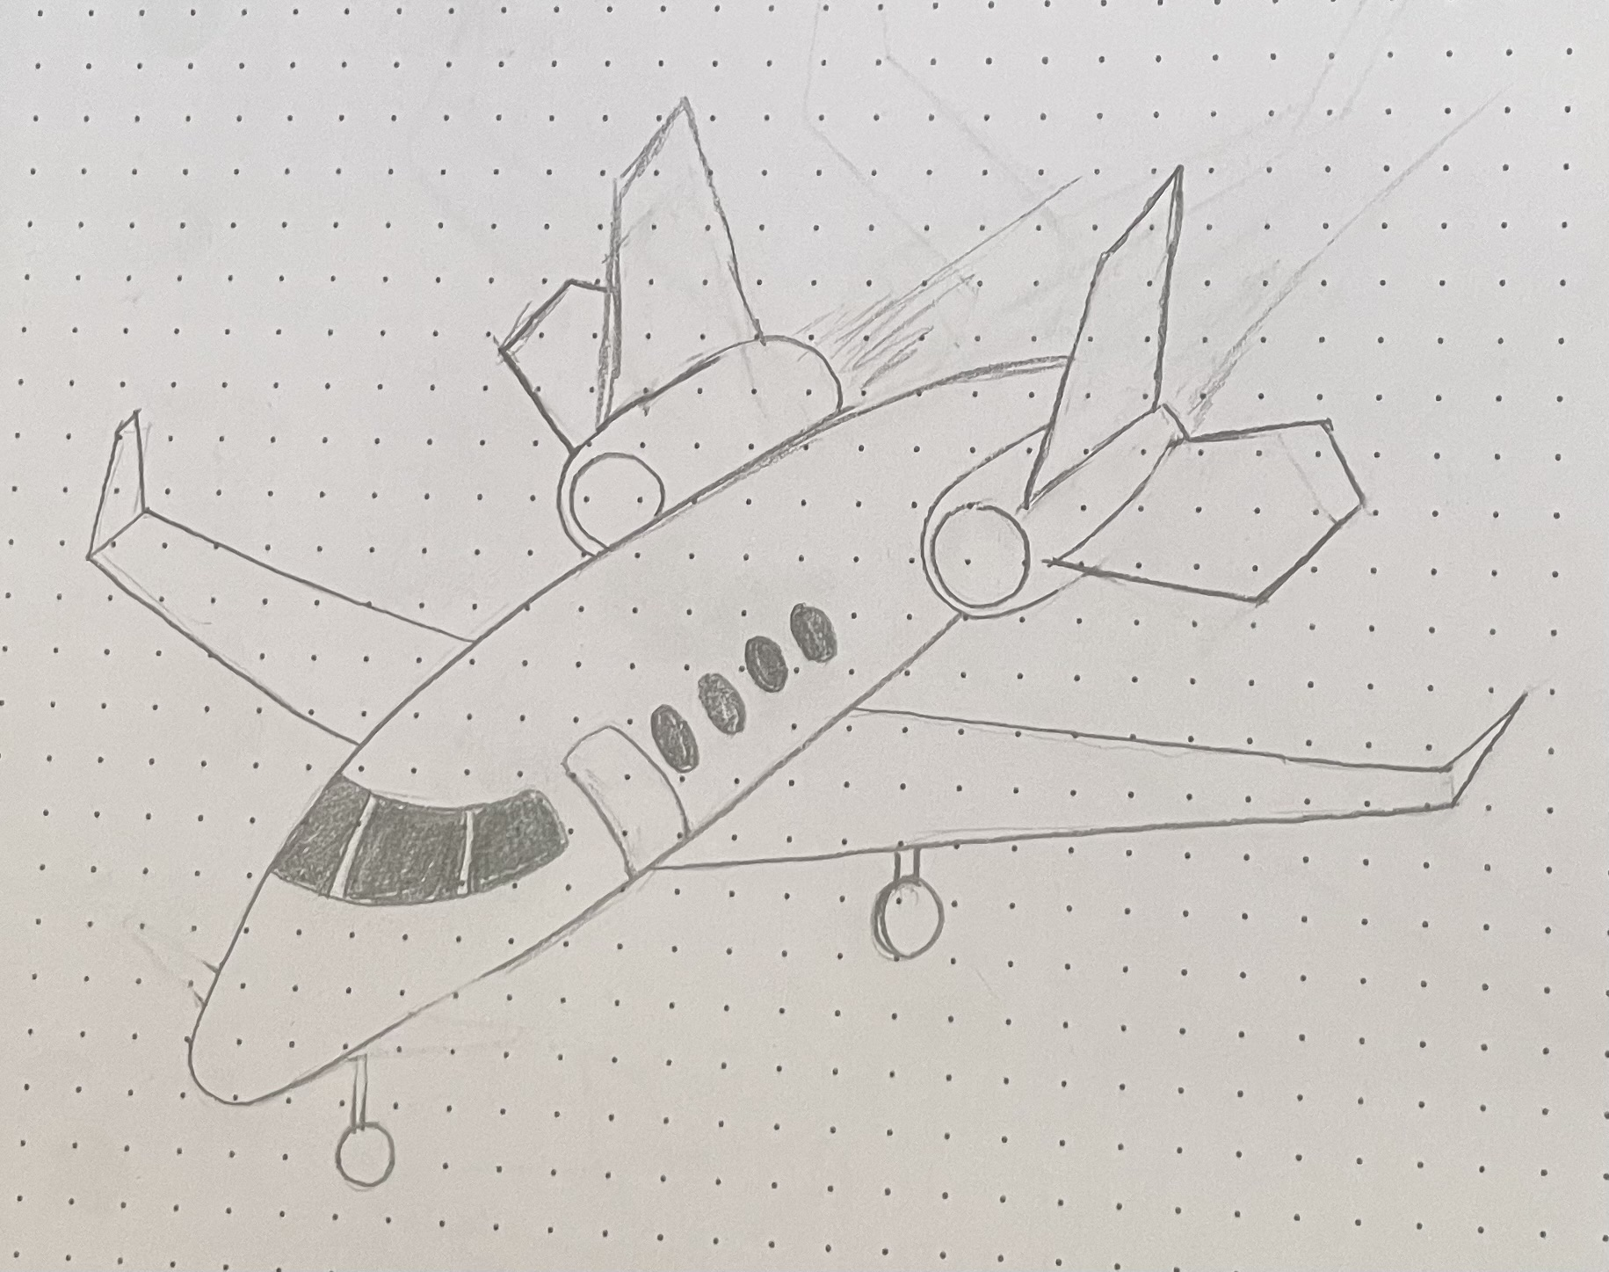

*Figure 4.6: Twin Tail and Horizontal Stabilizer Configuration*

The twin-tail and horizontal stabilizer configuration replaces a single vertical fin with two smaller vertical stabilizers, connected to the engines. It also includes two horizontal fins attached to engines as well as seen in figure 4.6. This concept was inspired by the Pegasus VBJ, a new business jet design that demonstrated the potential advantages of nonconventional tail layouts. The configuration provides additional directional stability, particularly useful at high angles of attack and can improve structural stiffness compared to a single large fin [5]. This design offers both advantages and challenges. Benefits include enhanced redundancy, potentially lower overall tail height for easier hangar compatibility, and reduced yaw sensitivity. However, drawbacks include higher structural and aerodynamic complexity, additional wetted area increasing drag, and greater manufacturing and maintenance costs compared to a conventional tail. For the mission parameters and performance requirements that must be met, however, this configuration would not be the optimal choice.

## 4.1.3 Over the Wing Engine Mount Configuration

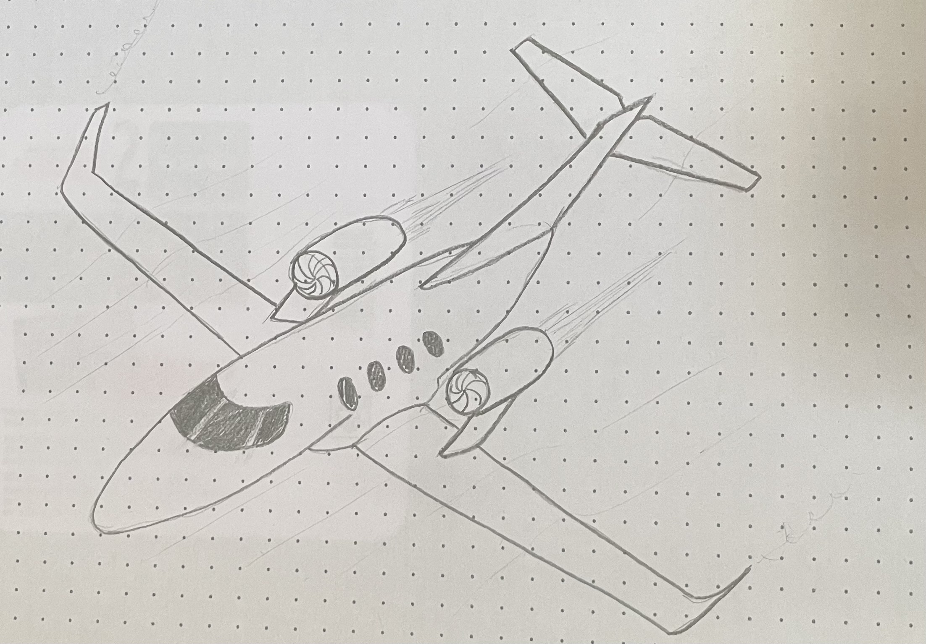

*Figure 4.7: Over the Wing Engine Mount Configuration*

The over-the-wing engine mount configuration situates two engines on pylons above a low-mounted wing. This configuration, most notably applied on the HondaJet, provides distinct advantages such as freeing fuselage volume for passengers and systems and reducing cabin noise levels. By leaving the fuselage clear of nacelles, the design can also improve aerodynamic efficiency and maintain a clean tail configuration. For the mission profile this concept has both strengths and weaknesses. On the positive side, the clean fuselage layout and low-wing design support efficient cruise performance and comfortable cabin arrangements, while winglets help extend range and improve climb efficiency. However, mounting engines over the wing introduces complex aerodynamic interactions, particularly with the high-lift system, which may compromise take-off and landing distances. The pylons and nacelles above the wing can also increase drag if not precisely placed. While the design offers potential performance benefits, the risks associated with short-field performance and aerodynamic integration make it less favourable for the specified mission requirements.

## 4.1.4 Tri-Jet Engine configuration

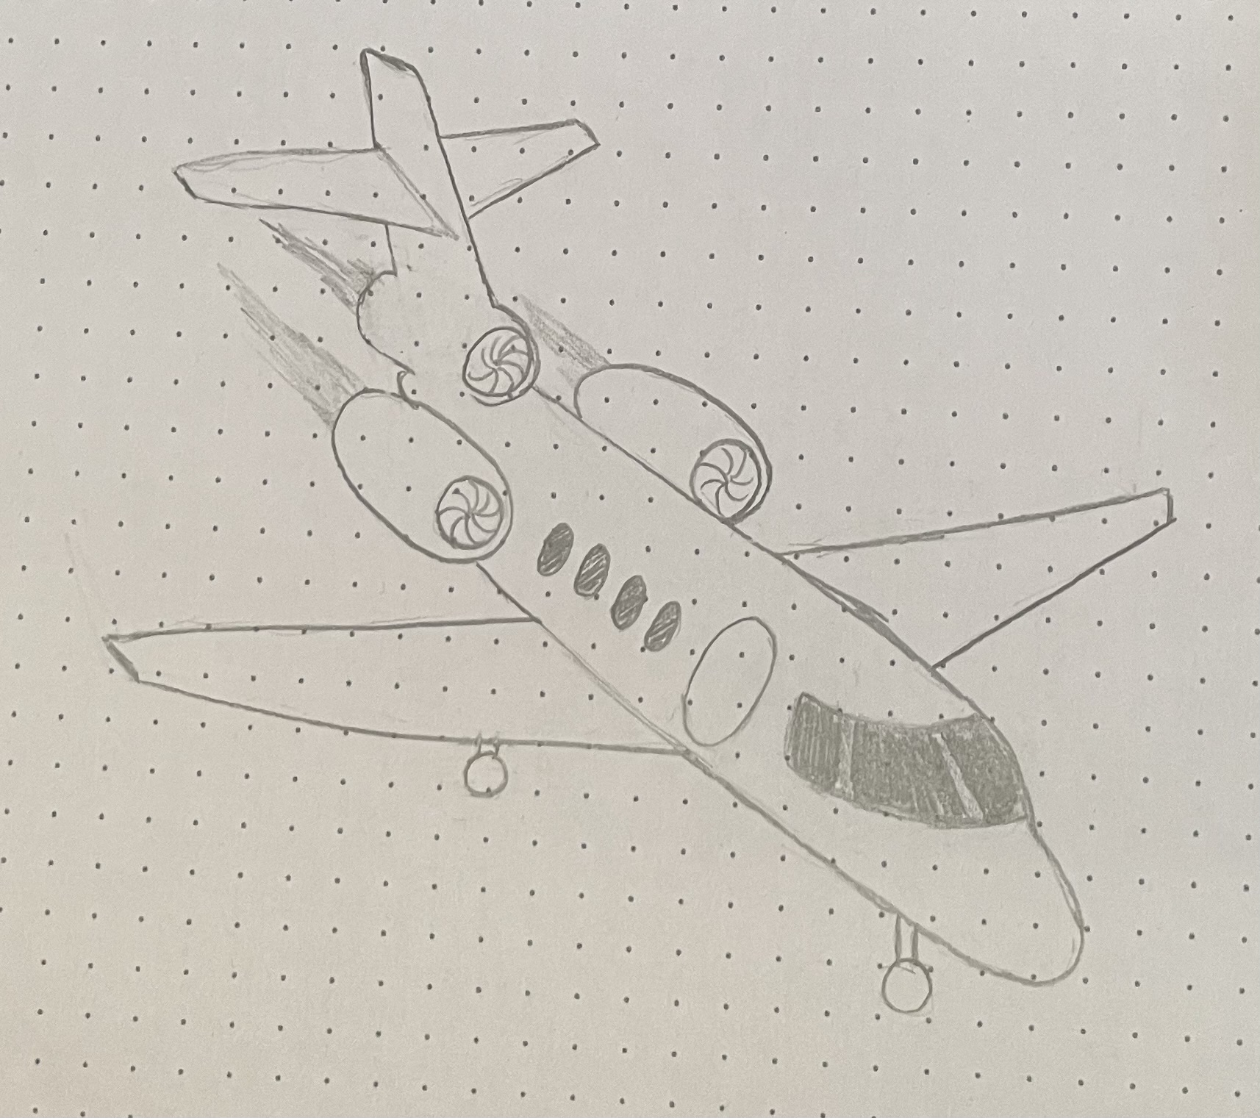

*Figure 4.8: Tri-Jet Engine Configuration*

The tri-jet engine configuration features three fuselage-mounted engines which was once popular in aircraft such as the Dassault Falcon 50 and Lockheed L-1011 due to its redundancy and improved one-engine-out performance. This can be advantageous for short-field operations and high-altitude airports. On the positive side, the third engine provides additional thrust, enhancing climb performance and safety in the event of an engine failure. It also allows for smaller individual engines, reducing ground clearance concerns. However, these advantages come with significant trade-offs. The additional engine adds structural complexity, weight, and drag, increasing operating costs and fuel burn, which could jeopardize meeting the 3,600 km range requirement without enlarging fuel capacity. Maintenance and certification processes are also more complex compared to twin-engine layouts, and market demand has shifted away from tri-jets in favour of more efficient twin engines. While technically capable of meeting mission requirements, the tri-jet configuration introduces multiple challenges that are not justified for this aircraft.

## 4.2 Concept Selection

The concept evaluation process involved a comparative analysis of four potential configurations. Each concept had its own strength and weaknesses relative to the mission requirements. The analysis focused on how each design does in terms of aerodynamics performance, structural complexity, passenger comfort, maintainability, and how closely its overall configuration matched with real time-tested designs.

Through this process, the rear-mounted twin jet configuration was identified as the optimal choice. While the other concepts such as the twin-tail offered potential improvements in stability, and the tri-jet provided redundancy and thrust margin, these benefits were outweighed by their disadvantages in drag, structural complexity, and efficiency. Similarly, the over-the-wing engine mount introduced innovative possibilities but carried significant aerodynamic and integration risks. The rear-mounted twin jet, however, demonstrated a superior balance of aerodynamic efficiency, passenger comfort, and operational feasibility, with clear precedent in successful business aircraft designs. As a result, it was selected as the most practical and reliable configuration to advance into the design phase.

# 5. Fuselage Design and Layout

## 5.1 Interior Fuselage Layout

## 5.1.1 Regulation Considerations

It is important to prioritize design limitations and regulations concerning the design of the fuselage. The regulatory requirements relating to cabin design would be 14 FAR Part 25.815 which requires that aisle width is at least 12 inches for 11 passengers through 19 passengers. As well as emergency exit requirements from FAR Part 25 which well be further investigated in 5.1.4

## 5.1.2 Cabin Design Approach

The design of the entire aircraft begins with the fuselage, and the fuselage design begins with an inside-out approach. The inside out approach begins with the payload & cabin specifications such as seat width, aisle width, aisle height, headroom, and seat pitch. Cabin dimensions in the fuselage are designed based off the required number of passengers onboard and comfortability. To determine cabin seat specs, we will use references of aircraft with similar requirements, pax and crew amount. If seat specs cannot be found, then cabin width and height will substitute

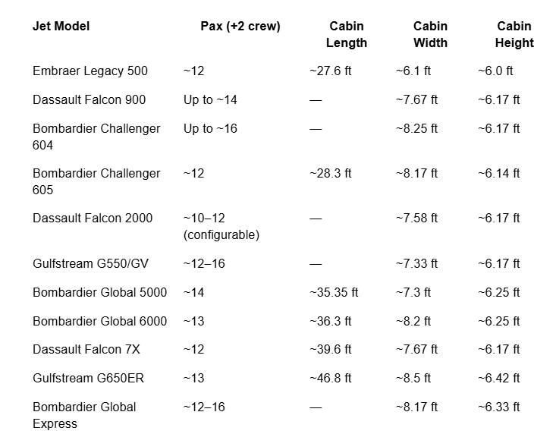

Table 5.1 Reference Cabin Measurements

Averaging the Cabin width and height of these chosen reference aircraft results in:

Cabin Width = 7.72 ft = 2.35 m

Cabin Height = 6.2 ft = 1.89 m

## 5.1.3 Fuselage Cross Section

Using the aisle height of 1.89m and cabin width of 2.35m, a cabin diameter of 2.62m was attained. A seat width of 0.66m was chosen based off a Sogerma business class seat providing comfort since the average human shoulder width is 0.41m. The aisle length was calculated subtracting the 2-seat width from the cabin width as well as an additional 0.04m for seat spacing resulting in an aisle width value of 0.9892m. Fuselage thickness should be estimated at 4% of the inner fuselage diameter resulting in a thickness of 0.1048m and an outer fuselage diameter of 2.829m. Floor thickness is 5% of cross section diameter resulting in 0.131m of thickness. There is also space below the floor of the cabin for extra cargo storage. Table 5.2 shows cabin measurements contributing to the design of the fuselage and Appendix 2.1 shows the fuselage cross section

|  |  |
| --- | --- |
| **Technical Specs** | **Value** |
| Cabin Width | 2.3492m |
| Cabin Height | 1.89m |
| Inner Fuselage Diameter | 2.62m |
| Outer Fuselage Diameter | 2.829m |
| Seat Width | 0.66m |
| Seat Height | 1.15m |
| Aisle Width | 0.9892m |
| Aisle Height | 1.89m |
| Floor Thickness | 0.131m |
| Fuselage Wall Thickness | 0.1048m |

Table 5.2 Cabin Measurements

## 5.1.4 Emergency Exits

It is important to have ease of access to emergency exits for safety of passengers as well as crew. According to CFR part 25.807, for aircraft carrying 10 to 19 passengers there must be at least one Type III emergency exit on each side of the fuselage. Type III emergency exit requires a rectangular opening of at least 20 inches wide and 36 inches high with corner radii not greater than seven inches. We have designed our exits to have a width of 23.62in/0.6m and a height of 63in/1.6m as displayed in Appendix 2.3.

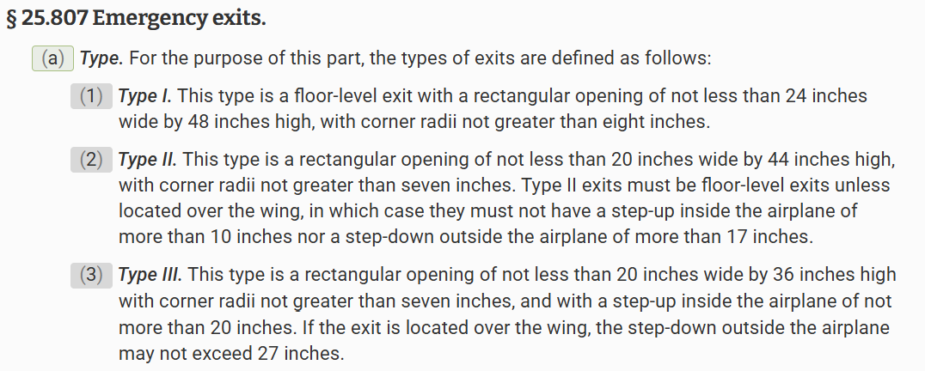

*Figure 5: Types of Emergency Exits*

## 5.1.5 Cabin Floor Plan

This is the primary intended layout of the cabin, including emergency exit placements, galley and storage spaces, a flight attendant lounge, a lavatory at the aft end, and a basic seating arrangement of 14. We designed the seat pitch to be 1.5m for space and comfort.

*Figure 5.1: Primary Cabin Floor Plan*

## 5.1.6 Design Flexibility

A key part of selling a design is illustrating versatility. Various possible layouts are possible in the cabin, with these 3 examples demonstrating available usages of the cabin space.

Alternate Layout 1: Mixed Comfort

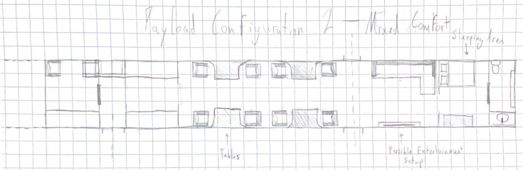

*Figure 5.2: Alternate Floor Plan 1*

This layout provides a mixture of workspace and leisure space, as well as a sleeping area in the aft portion of the cabin.

Alternate Layout 2: Business Spaces

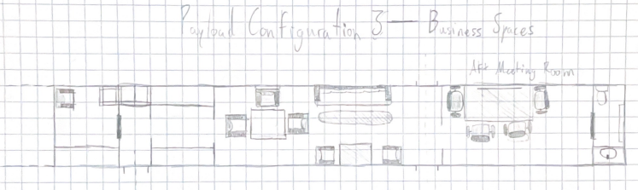

*Figure 5.3: Alternate Floor Plan 2*

This layout has plenty of workspace, including different worktables as well as a separate meeting room that can be closed off if privacy is needed.

Alternate Layout 3: Leisure

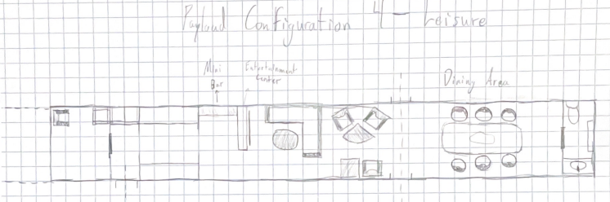

*Figure 5.4: Alternate Floor Plan 3*

This layout is purely leisure, with entertainment space, talking circles, and even a dining area.

It is important for an aircraft to be versatile to meet a broader spectrum of needs, not only in performance but also in passenger usage. Business jets are used for many reasons, and the space must be able to accommodate as many as possible. These alternate configurations demonstrate that many combinations of seating, tables, entertainment space, dining space, and other such additions can be used within the available space.

## 5.1.7 Visibility & Cockpit/Nose Design

The Cockpit is designed from the inside out beginning with the pilot's line of sight which involves an anthropometric approach. “The controls must be located and arranged so that the pilot, when seated, has full and unrestricted movement of each control without interference from either his clothing or the cockpit structure.” (14 CFR §23.777(b)). We used a 5’10 pilot for reference which is 1.778m in height, and if a pilot of 5’10 is sitting we estimate a sitting height of 18 in and hip to eye level measurement of 29 in. Combining the measurements results in a floor to eye level value of 47 in/1.19m. From eye to relaxed arm length of 17 in and eye to extended arm length is 22 in. These measurements will help us determine visibility and design the cockpit appropriately.

Using Figure 5.5 from blackboard we needed an over nose angle greater than 10 degrees, so we chose 13 degrees. A grazing angle 31 degrees was chosen, and an upward angle of 21 degrees was chosen. The flight deck was chosen to be 130 in/3.3 m since we have 3 crew members on board as displayed in Appendix 2.3

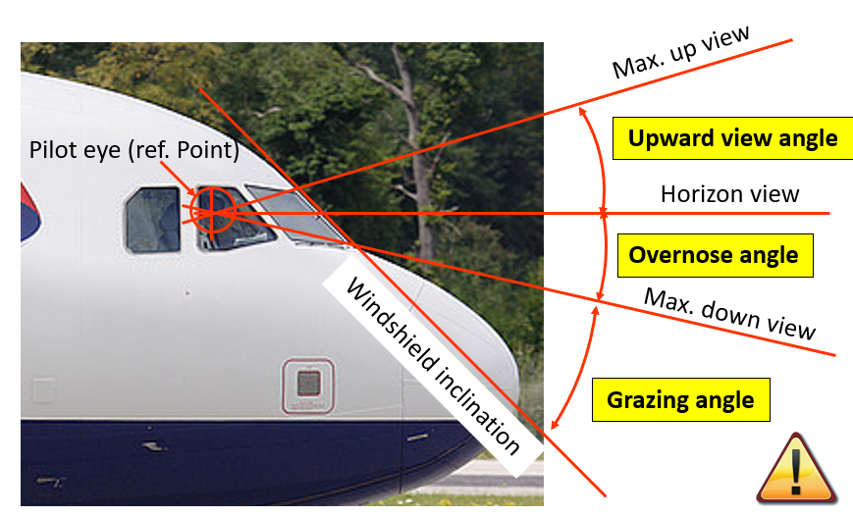

*Figure 5.5: Over Nose Angle Chart*

## 5.2 Nose length

The nose length can be viewed as an extension of the fuselage which means were controlling how much longer the fuselage should be which directly affect the overall fineness ratio. The fineness ratio affects aerodynamic performance of aircraft and should fit within an acceptable range. We aimed for a fineness ratio of 2.5 because an acceptable range according to BB lecture notes is 1.2-2.5. This allowed all our fineness ratio to remain consistent within the required fineness ratio range across the aircraft. With a fixed diameter of 2.83m and a desired fineness ratio of 2.5, the calculations resulted in the nose length being less than 7.075 m. The nose length we designed has a length of 5.3m to allow length for the tail cone and enough space for the crew which was recommended to be 3.3m for a crew of 3. View Appendix 2.3 to view overall fuselage lengths including the nose.

## 5.2.1 Tail Plane & Wings

Reliable data for the wing root chord length of typical business jets is limited, so this parameter was estimated at 2.1 m. Similarly, since published information on wing sweep angles is not readily available, a sweep angle of 20° was assumed as a reasonable starting point, with the accuracy of this choice to be validated later in the design process. Lastly, the tail span was approximated at 7 m, based on the proportions of comparable aircraft documented in the reference data set provided in Appendix 1.

## 5.2.2 Tail Design

The tail design stems from specific fineness ratios and angle constraints to meet both aerodynamic and operational requirements. A tail fineness ratio is the ratio so tail length to maximum fuselage diameter. According to the Power Point Presentation a business jet usually has a fineness ratio between 2.5 and 5 [6]. This aircraft has a diameter of 2.83m and with an estimated fineness ratio of 2.5, the calculated tail cone length would be 7.075 m. Furthermore, two angular requirements must also be applied to the tail design. The rotation angle must be equal to or greater than 14° to prevent the tail from striking the runway during take-off. Based on the current configuration the aircraft has a rotation angle of 14°. The divergence angle, which affects aerodynamics performance, must be less than 24°. For this design a divergence angle of 22.57° was selected. Additional calculations will be conducted later in the design process to either validate these assumed values or adjust them as necessary to ensure better alignment with the overall design.

## 5.2.3 Landing Gear

A tricycle landing gear configuration was chosen as it is the most popular amongst business jets and is the most reliable for the mission requirements. The main gear will be places under the wings, while the nose gear will be placed below the cockpit. The gear will be retractable to prevent aerodynamics drag during flight and will retract into its specified location. To maintain the required rotation angle of 14 degrees, the height of the landing gears are valued at 2.142 m The precise placement and sizing of the landing gear is unknown but will be calculated further in the design process. Approximate location placements and measurements can be seen in the Front View Technical Drawing in Appendix 2.

# Sources and References:

**Reference Aircraft Data Sources:**

<https://www.embraer.com/executive-jets-our-aircraft/phenom-300e/en/>

<https://www.aircharterserviceusa.com/aircraft-guide/private/fairchild-usa/fairchild-dornier-d328-jet-envoy>

<https://www.skyart.com/sogerma-business-class-lie-flat-seat-single-genuine-leather>

<https://www.ecfr.gov/current/title-14/chapter-I/subchapter-C/part-25/subpart-D/subject-group-ECFR88992669bab3b52/section-25.807>

<https://www.globalair.com/aircraft-for-sale/specifications?specid=1230>

<https://www.globalair.com/aircraft-for-sale/specifications?specid=1795> <https://www.globalair.com/aircraft-for-sale/specifications?specid=639>

<https://jetav.com/adam-aircraft-a700-specs-and-description/>

<https://jetadvisors.com/jet/westwind-2/>

<https://www.globalair.com/aircraft-for-sale/specifications?specid=79>

<https://pimaair.org/museum-aircraft/beechcraft-starship/>

<https://advancedairlines.com/aircraft-sales/2011-bombardier-challenger-300-n332ar/>

<https://bombardier.com/en/aircraft/global-8000#bba-pdp-section-5> <https://www.globalair.com/aircraft-for-sale/specifications?specid=640> <https://www.globalair.com/aircraft-for-sale/specifications?specid=26> <https://www.globalair.com/aircraft-for-sale/specifications?specid=32> <https://cessna.txtav.com/en/citation/m2-gen3>

<https://www.globalair.com/aircraft-for-sale/specifications?specid=1004>

<https://cessna.txtav.com/en/citation/latitude>

<https://altivationaircraft.com/citation-xls/>

<https://cirrusaircraft.com/aircraft/vision-jet/>

[https://www.guardianjet.com/jet-aircraft-online-tools/aircraft-brochure.cfm?m=Dassault-Falcon-50EX 97](https://www.guardianjet.com/jet-aircraft-online-tools/aircraft-brochure.cfm?m=Dassault-Falcon-50EX-97)

<https://www.dassaultfalcon.com/businessjets/falcon-2000lxs/>

<https://jetadvisors.com/jet/eclipse-ea500/>

<https://www.aopa.org/-/media/Files/AOPA/Home/News/All-News/2010/Phenom-300-debut/Embraer_Phenom_300_Specsheet.pdf> <https://daflwcl3bnxyt.cloudfront.net/m/2c77c79d8706861/original/Legacy-450-brochure.pdf> <https://www.aircharterserviceusa.com/aircraft-guide/private/fairchild-usa/fairchild-dornier-d328-jet-envoy>

<https://www.globalair.com/aircraft-for-sale/specifications?specid=604> <https://www.globalair.com/aircraft-for-sale/specifications?specid=643> <https://en.wikipedia.org/wiki/Honda_HA-420_HondaJet>

<https://www.globalair.com/aircraft-for-sale/specifications?specid=36> <https://www.globalair.com/aircraft-for-sale/specifications?specid=1390>

<https://www.pilatus-aircraft.com/en/pc-24/technical-data>

<https://www.lunajets.com/en/news/how-much-luggage-on-a-private-jet>

[Long-haul First Class Comparison Chart - SeatGuru](https://www.seatguru.com/charts/longhaul_first_class.php)

[1] <https://www.google.com/url?sa=i&url=https%3A%2F%2Fcessna.txtav.com%2Fen%2Fcitation%2Fcj4-gen2&psig=AOvVaw0LFsRqX8gf7jiYVVNyBruK&ust=1757713014333000&source=images&cd=vfe&opi=89978449&ved=0CBkQjhxqFwoTCLj-hrHV0Y8DFQAAAAAdAAAAABAE>

[2] <https://newatlas.com/aircraft/pegasus-vertical-business-jet-evtol-turboshaft/>

[3] <https://www.hondajet.com/en/Pre-Owned-Aircraft>

[4]<https://theaviationist.com/2023/02/09/the-italian-air-force-dassault-falcon-fleet-reaches-150k-flight-hours/>

[5]<https://pegasusua.com/wp-content/uploads/2021/03/Pegasus-Universal-Aerospace_Business-Presentation.pdf>

[6]<https://1drv.ms/p/c/dbab723b8bc09683/EViG5ka7X_VDk1lRiP5aX3UB2k4XNzIOJtMiGdPD6ZTTvQ?e=vviX8P&nav=eyJzSWQiOjUzOSwiY0lkIjoyMjA4MDM0NTI2fQ>

# Appendix 1: Aircraft parameters table

|  |  |  |  |
| --- | --- | --- | --- |
| Symbol | Parameters/Characteristic | Value | Unit |
| Aircraft Wing geometry | | | |
| b | Wing span | 21.88 | m |
| S | Wing area |  |  |
| A | Aspect ratio |  |  |
| L | Wing sweep angle | 20 | degrees |
| Etc. | Etc. |  |  |
|  |  |  |  |
|  | | | |
|  |  |  |  |
|  |  |  |  |
|  |  |  |  |
|  |  |  |  |
| Weights and loadings | | | |
| WE | Empty weight |  |  |
| WMTO | Maximum take-off weight |  |  |
| W/S | (maximum) Wing loading |  |  |
| Etc. | Etc. |  |  |
| Flight parameters | | | |
| hcruise | Cruise altitude |  |  |
| Vcruise | Cruise speed | 830 | km/h |
| CLcruise | Cruise lift coefficient |  |  |
| CLmax | Maximum lift coefficient (take-off) |  |  |
| sTO | Take-off distance | 1200 | m |
| sL | Landing distance | 860 | m |
|  |  |  |  |
|  |  |  |  |
| Etc. | Etc. | Etc. | Etc. |
|  |  |  |  |
|  |  |  |  |
|  |  |  |  |

# Appendix 2: Aircraft technical drawings

The following appendices contain technical drawings of the aircraft done in Autodesk Inventor

2026.

**Appendix 2.1 Fuselage Front Cross Section**

**Appendix 2.2 Aircraft Front View**

**Appendix 2.3 Aircraft Side View**

**Appendix 2.4 Aircraft Top View**

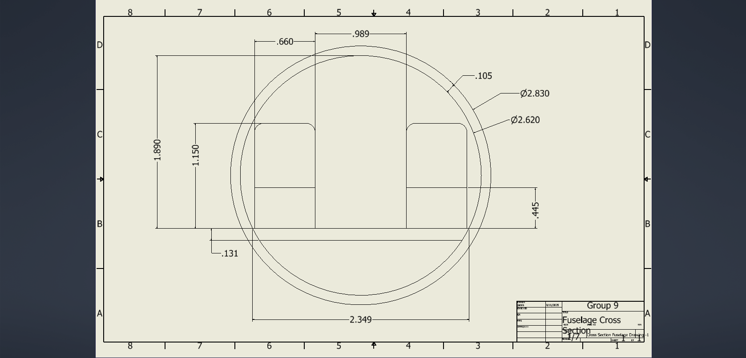

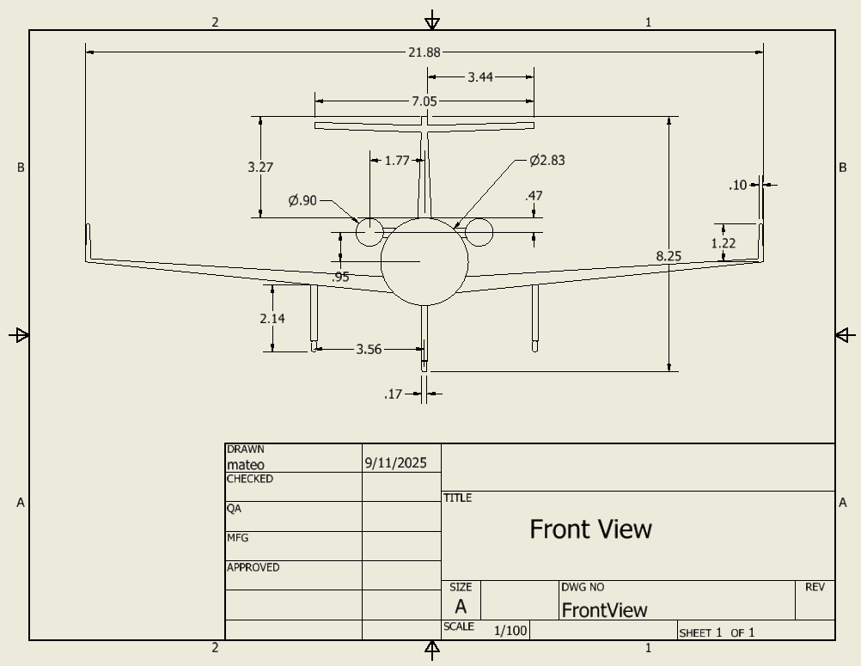

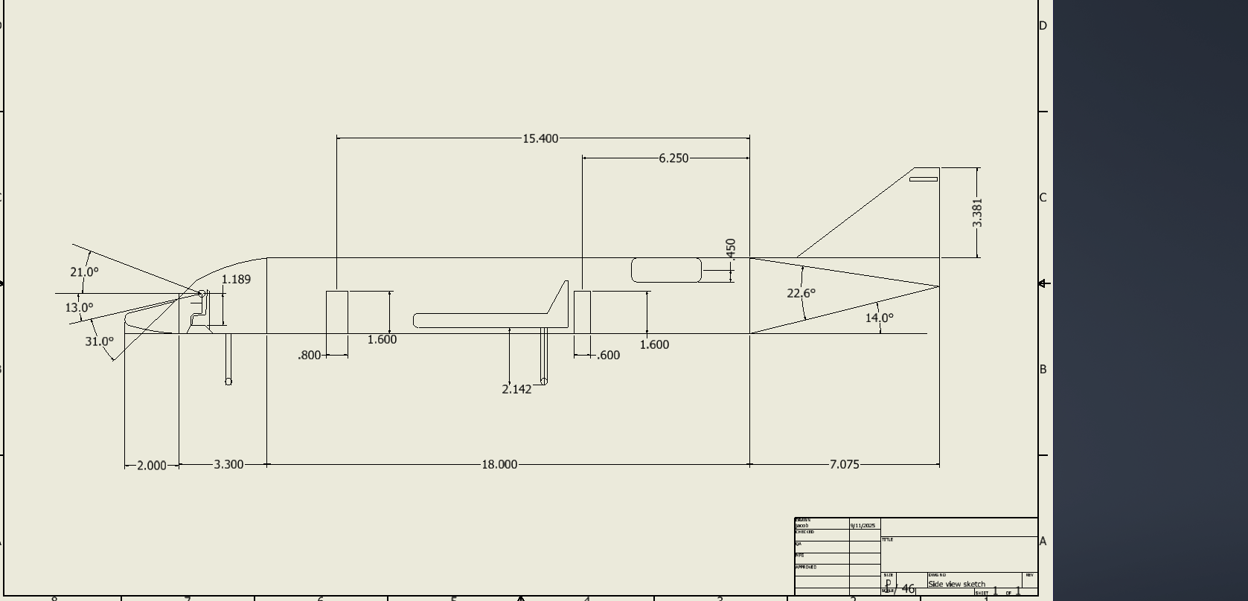

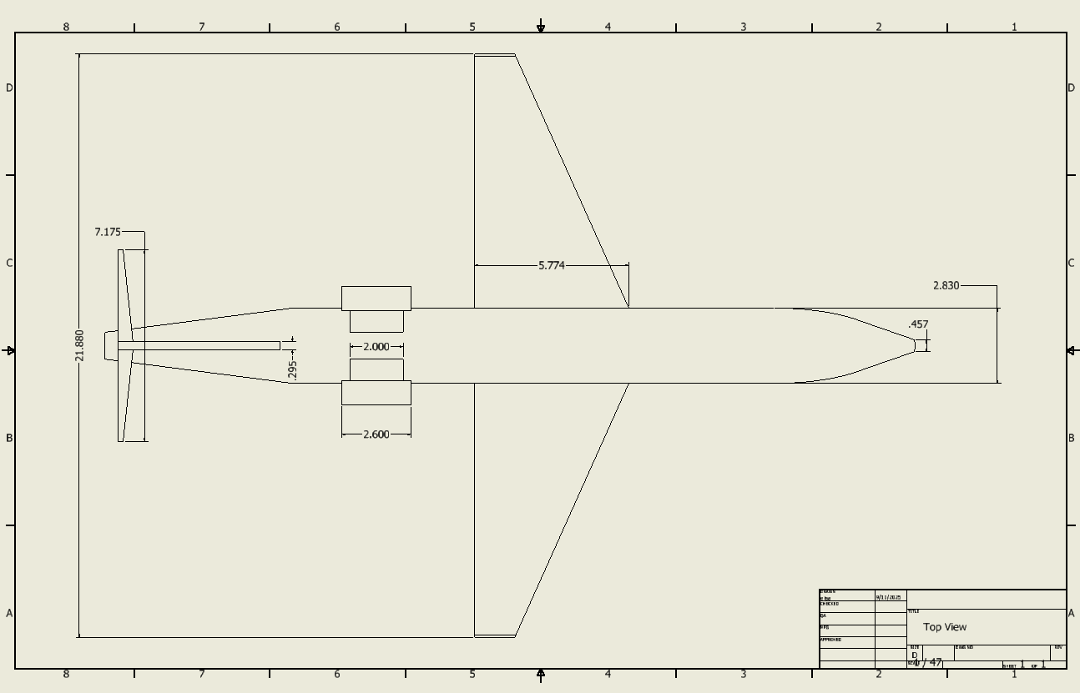

# Appendix 3: Table of Reference Aircraft

|  |  |  |  |  |  |  |  |  |  |  |  |  |  |
| --- | --- | --- | --- | --- | --- | --- | --- | --- | --- | --- | --- | --- | --- |
| Year of Entry | Manufacturer | Type | Crew | Passengers | MTOW (kg) | BOW (kg) | Max Payload(kg) | Fuel (kg) | Range (km) | Cruise Speed (km/h) | Take off Distance (m) | Landing Distance (m) | Operative Altitude (ft) |
| 1987 | Airbus | A320 | 3 | 180 | 78000 | 42,600 | 18205 | 23963 | 9167400 | 870 | 1850 | 1359 | 39698 |
| 2007 | Adam Aircraft | A700 | 2 | 6 | 3855 | 2495 | 885 | 1003 | 2593 | 615 | 1036 | 823 | 41000 |
| 1980 | Aero Commander | IAI Westwind II | 2 | 7 | 7620 | 5995 | 1428 | 4327 | 3982 | 745 | 1280 | 564 | 45000 |
| 1998 | Beechcraft | Premier 1 | 1 | 7 | 5670 | 3810 | 712 | 1665 | 2648 | 789 | 1156 | 968 | 41000 |
| 1986 | Beechcraft | Starship | 2 | 6 | 6759 | 4681 | 1034 | 1717 | 2124 | 620 | 1247 | 802 | 41000 |
| 2003 | Bombardier | Challenger 300 | 2 | 8 | 17622 | 11022 | 1588 | 6418 | 5700 | 852 | 1509 | 732 | 45000 |
| 1996 | Bombardier | Challenger 604 | 2 | 12 | 21,863 | 12,292 | 2,223 |  |  |  |  |  |  |
| 2025 | Bombardier | Global 8000 | 2 | 17 | 47536 |  | 2585 | 22203 | 14800 | 1160 | 1756 | 677 | 43000 |
| 1966 | Bombardier | Learjet 24 | 2 | 5 | 6123 | 3552 | 1619 | 2553 | 2728 | 774 | 1033 | 1008 | 45000 |
| 1995 | Bombardier | Learjet 45 | 2 | 9 | 9752 | 6300 | 1002 | 2750 | 3167 | 804 | 1644 | 750 | 51000 |
| 1993 | Bombardier | Learjet 60 | 2 | 8 | 10659 | 6700 | 1011 | 3588 | 4463 | 840 | 1661 | 917 | 51000 |
| 1993 | Cessna | Citation M2 | 1 | 7 | 4853 | 3171 | 685 | 233 | 2871 | 748 | 978 | 789 | 41000 |
| 2010 | Cessna | Citation CJ4 | 2 | 10 | 7761 | 4663 | 1007 | 2644 | 4010 | 835 | 1039 | 896 | 45000 |
| 2015 | Cessna | Citation Latitude | 2 | 9 | 13971 | 8462 | 1258 | 5168 | 5000 | 826 | 1091 | 756 | 45000 |
| 2008 | Cessna | Citation XLS+ | 2 | 12 | 9163 | 5833 | 1016 | 3057 | 3889 | 817 | 1085 | 969 | 45000 |
| 2016 | Cirrus | Vision SF50 | 1 | 6 | 2722 | 1649 | 602 | 910 | 2222 | 440 | 973 | 917 | 28000 |
| 1997 | Dassault Falcon | 50EX | 2 | 9 | 18098 | 10092 | 1506 | 7040 | 5982 | 889 | 1509 | 666 | 49000 |
| 1986 | Dassault Falcon | 900 | 2 | 12-19 | 20,640 | 11,203 | 1604 | 9,482 | 8797 | 893 | 1633 | 745 | 51,000 |
| 2012 | Dassault Falcon | 2000 LXS | 2 | 10 | 19414 | 11227 | 2722 | 7557 | 7408 | 851 | 1425 | 689 | 47000 |
| 2002 | Eclipse | EA500 | 2 | 5 | 2721 | 1739 | 494 | 770 | 2084 | 685 | 715 | 686 | 41000 |
| 2009 | Embraer | Phenom 300E | 2 | 10 | 8150 | 5344 | 1196 | 2428 | 3650 | 859 | 978 | 677 | 45000 |
| 2015 | Embraer | Legacy 450 | 2 | 9 | 16000 | 10400 | 1325 | 5839 | 5378 | 856 | 1191 | 637 | 45000 |
| 2014 | Embraer | Legacy 500 | 2 | 8-12 | 17,400 | 12,020 | 1300 | 5,920 | 5790 | 862 | 1245 | 647 | 45,000 |
| 1998 | Fairchild Dornier | 328Jet | 3 | 15 | 15660 | 9420 | 3650 | 3634 | 2222 | 740 | 1367 | 1306 | 35000 |
| 1994 | Gulfstream | G100 (Astra) | 2 | 7 | 11181 | 6515 | 1195 | 4248 | 5462 | 896 | 1828 | 797 | 45000 |
| 2002 | Gulfstream | G150 | 2 | 8 | 11839 | 6849 | 1088 | 4672 | 5111 | 850 | 1524 | 1234 | 45000 |
| 1999 | Gulfstream | G200 | 2 | 8 | 16079 | 9049 | 1837 | 6803 | 5797 | 850 | 1854 | 1326 | 45000 |
| 1993 | Hawker | 1000A | 2 | 8 | 14107 | 8232 | 975 | 5189 | 5500 | 814 | 1814 | 1193 | 43000 |
| 2004 | Hawker | 400XP | 2 | 9 | 7394 | 4983 | 914 | 2228 | 4000 | 828 | 1374 | 889 | 45000 |
| 2015 | Honda | HA-420  HondaJet | 2 | 6 | 4854 | 3303 | 635 | 1290 | 2661 | 782 | 1219 | 914 | 43000 |
| 1979 | Lockheed | JetStar II | 2 | 9 | 201885 | 11566 | 907 | 8149 | 4820 | 811 | 1600 | 1189 | 43000 |
| 2013 | Nextant | 400XTi | 2 | 9 | 7394 | 4776.8 | 1120 | 2228 | 3430 | 852 | 1164 | 883 | 45000 |
| 2018 | Pilatus | PC-24 | 2 | 10 | 8500 | 5316 | 1406 | 2705 | 3704 | 815 | 940 | 735 | 45000 |

|  |  |  |  |  |  |  |  |  |
| --- | --- | --- | --- | --- | --- | --- | --- | --- |
| **Aircraft Manufacturer** | **Engines** | **Engines Manufacturer** | **Engine Model** | **Engine Diameter (m)** | **Static Thrust (kN)** | **Wingspan (m)** | **Length (m)** | **Height (m)** |
| Airbus | 2 | CFM International | CFM56-5B4 | 1.73 | 120 | 33 | 37.5 | 11.8 |
| Adam Aircraft | 2 | Williams | FJ33 | 0.47 | 8.21 | 13.41 | 12.42 | 2.92 |
| Aero Commander | 2 | Honeywell | TFE 731-3 | 0.787 | 16 | 13.66 | 15.93 | 4.83 |
| Beechcraft | 2 | Williams | FJ44-2A | 0.55 | 15.17 | 13.56 | 14.02 | 4.67 |
| Beechcraft | 2 | Pratt & Whitney | PT6A-67A | 0.48 |  | 16.6 | 14.05 | 3.94 |
| Bombardier | 2 | Honeywell | HTF7000 | 0.87 | 30 | 19.46 | 20.92 | 6.2 |
| Bombardier | 2 | GE | Passport | 0.13 | 70 | 31.7 | 33.9 | 8.1 |
| Bombardier | 2 | GE | CJ610 | 0.45 | 14 | 10.84 | 13.23 | 3.73 |
| Bombardier | 2 | Honeywell | TFE731-20BR | 1 | 15.57 | 14.58 | 17.78 | 4.29 |
| Bombardier | 2 | Pratt & Whitney | PW305A | 0.91 | 21.13 | 13.34 | 17.88 | 4.47 |
| Cessna | 2 | Williams | FJ44-1AP-21 | 0.58 | 8.74 | 14.39 | 13 | 4.2 |
| Cessna | 2 | Williams | FJ44-4A | 0.58 | 16 | 15.77 | 16.26 | 4.7 |
| Cessna | 2 | Pratt & Whitney | PW306D1 | 0.97 | 26.28 | 22.05 | 19 | 6.4 |
| Cessna | 2 | Pratt & Whitney | PW545C | 0.688 | 18.32 | 17.17 | 16 | 5.23 |
| Cirrus | 1 | Williams | FJ33-5A | 0.47 | 8.23 | 11.79 | 9.42 | 3.32 |
| Dassult Falcon | 3 | Honeywell | TFE731-40 | 1 | 18.9 | 18.86 | 18.5 | 7 |
| Dassult Falcon | 2 | Pratt & Whitney | PW308C | 1.17 | 31.14 | 21.38 | 20.23 | 7.11 |
| Eclipse | 2 | Pratt & Whitney | PW610F | 0.356 | 4.226 | 11.6 | 10.2 | 3.4 |
| Embraer | 2 | Pratt & Whitney | PW535E1 | 1.18 | 15.47 | 15.9 | 15.65 | 5.11 |
| Embraer | 2 | Honywell | HTF7500E | 0.86 | 29.9 | 20.25 | 19.68 | 6.43 |
| Fairchild Dornier | 2 | Pratt & Whitney | PW306B | 0.97 | 23.24 | 20.98 | 21.2 | 7.24 |
| Gulfstream | 2 | Honywell | TFE 731-40R | 1 | 18.9 | 16.64 | 16.94 | 5.54 |
| Gulfstream | 2 | Honeywell | TFE 731-40AR | 1 | 18.9 | 16.64 | 16.94 | 5.54 |
| Gulfstream | 2 | Pratt & Whitney | PW306A | 0.97 | 26.9 | 17.7 | 18.9 | 6.4 |
| Hawker | 2 | Pratt & Whitney | PW305B | 0.914 | 23.4 | 15.5 | 15.85 | 5.18 |
| Hawker | 2 | Pratt & Whitney | JT15D-5R | 0.69 | 13.18 | 13.1 | 14.6 | 3.96 |
| Honda | 2 | GE Honda | HF120 | 0.53 | 9.32 | 11.88 | 12.8 | 14.27 |
| Lockheed | 4 | Honeywell | TFE731-3 | 1 | 16 | 16 | 16.59 | 18.41 |
| Nextant | 2 | Williams | FJ44-3AP | 0.55 | 13.6 | 13.1 | 14.63 | 3.96 |
| Pilatus | 2 | Williams | FJ44-4A-QPM | 0.58 | 15.17 | 16.89 | 16.76 | 5.18 |